Bug Report – ShopEasy Website

**Bug 1**

**Bug ID:** BUG-001  
**Summary:** "Login button is not clickable on the login page"

**Steps to Reproduce:**

1. Navigate to https://shopeasy-demo.com/login
2. Enter valid username and password
3. Try to click the "Login" button

**Expected Result:**  
User should be able to click the login button and get redirected to the homepage/dashboard.

**Actual Result:**  
The "Login" button is disabled and cannot be clicked, even with valid credentials.

**Severity:** **High** (blocks user login)

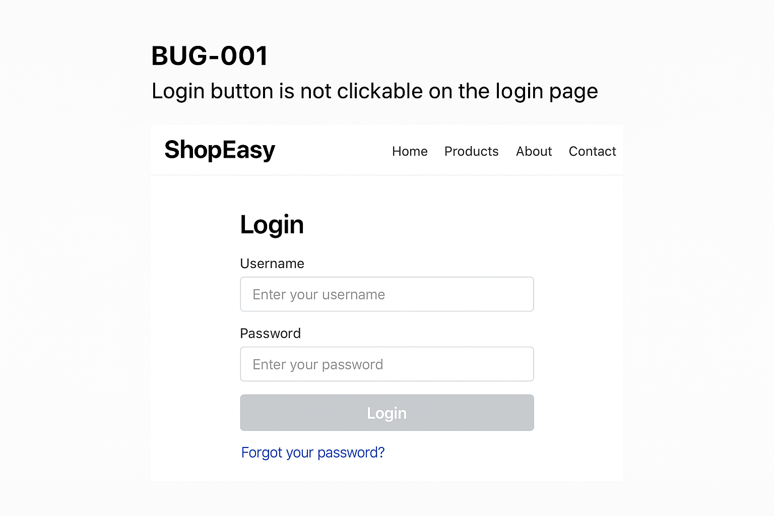

**Bug 2**

**Bug ID:** BUG-002  
**Summary:** "Product images not loading on homepage"

**Steps to Reproduce:**

1. Navigate to https://shopeasy-demo.com/home
2. Scroll down to the "Featured Products" section
3. Observe the product thumbnails

**Expected Result:**  
All product images should load properly.

**Actual Result:**  
Some product thumbnails show a **broken image icon** instead of the product picture.

**Severity:** **Medium** (affects user experience but does not block core functionality)

